DATA SCIENCE TOOLBOX: PYTHON PROGRAMMUNG
PROJECT REPORT
(Project Semester January-April 2026)

Vehicle Fitness Data Analysis and Prediction Using EDA and Linear Regression

Submitted by

N.Raghavendra Reddy

Registration No:12408553

Programme and Section: B. Tech CSE,324AO
Course Code INT375

Under the Guidance of

Dr.Gargi Sharma

Discipline of CSE/IT

Lovely School of Computer Science and Engineering

Lovely Professional University, Phagwara

CERTIFICATE

This is to certify that Adi Jaideep bearing Registration no. 12409216 has completed INT375 project titled, “Vehicle Fitness Data Analysis and Prediction Using EDA and Linear Regression
” under my guidance and supervision. To the best of my knowledge, the present work is the result of his/her original development, effort and study.

Signature and Name of the Supervisor
Designation of the Supervisor
School of Computer Science and Engineering
Lovely Professional University
Phagwara, Punjab.

Date: 22-04-2026

DECLARATION

I, Raghavendra Reddy student of Computer Science and Engineering under CSE/IT Discipline at, Lovely Professional University, Punjab, hereby declare that all the information furnished in this project report is based on my own intensive work and is genuine.

Date: Signature
Registration No. 12408553 N. Raghavendra reddy

ACKNOWLEDGEMENT
I would like to express my sincere gratitude to my project guide Dr. Mrinalini Rana for their invaluable guidance, continuous support, and encouragement throughout the completion of this project. Their expertise and constructive feedback have been instrumental in shaping this work.
I am also thankful to the Department of Computer Science and Engineering, Lovely Professional University, for providing the necessary resources and infrastructure that facilitated this research.
I extend my appreciation to my family and friends for their moral support and understanding during the course of this project.
Finally, I acknowledge all the authors and researchers whose works have been cited in this report, as their contributions have provided the foundation for this study.
N. Raghavendra Reddy
12408553

TABLE OF CONTENTS
Chapter | Title | Page No.
 | Certificate | ii
 | Declaration | iii
 | Acknowledgement | iv
 | Table of Contents | v
 | List of Figures | vii
 | List of Tables | viii
 | Abstract | ix
1 | Introduction
2 | DATASET DESCRIPTION
3 | METHODOLOGY
4 | EXPLORATORY DATA ANALYSIS WITH GRAPHS
5 | MACHINE LEARNING MODEL
6 | RESULTS AND DISCUSSION
7 | CONCLUSION
8 | FUTURE WORK
9 | REFERENCES

Introduction .
Vehicle fitness certification plays a crucial role in ensuring road safety, environmental compliance, and proper functioning of transportation systems. Governments and transport authorities maintain large volumes of vehicle inspection data, which can be analyzed to extract useful insights for decision-making. However, raw data alone is insufficient unless processed and visualized effectively.
In this project, data analysis techniques are applied to understand vehicle fitness patterns. The use of visualization helps in identifying trends and anomalies, while machine learning provides predictive capabilities. The study focuses on analyzing fitness status, vehicle class distribution, regional variations, and temporal trends. By combining EDA and machine learning, this project demonstrates the importance of data-driven approaches in transportation systems.

DATASET DESCRIPTION
The dataset used in this project consists of vehicle fitness records containing multiple attributes such as registration number, vehicle class, fitness status, validity start date, validity end date, and regional office codes. These attributes provide a comprehensive view of vehicle inspection records.
Before analysis, the dataset required preprocessing to ensure consistency. Date columns such as validFrom, validTo, and fromdate were converted into datetime format to enable accurate time-based calculations. The dataset does not contain significant missing values, making it suitable for analysis.
Feature engineering was performed to create new variables such as vehicle age and validity duration. Vehicle age was calculated using the difference between the current year and the registration year, while validity duration was calculated as the difference between validity start and end dates. These features played a key role in both analysis and predictive modeling.

METHODOLOGY
The methodology of this project consists of four major stages: data preprocessing, feature engineering, data visualization, and machine learning modeling.
In the preprocessing stage, data cleaning techniques were applied to ensure that all columns were in the correct format. Invalid or inconsistent values were handled appropriately. Feature engineering was then performed to derive meaningful variables such as vehicle age and validity duration.
The visualization stage involved the use of various graphs to understand patterns in the dataset. Bar charts were used for categorical comparisons, line graphs were used for trend analysis, histograms were used for distribution analysis, and scatter plots were used to study relationships between variables.
Finally, a Linear Regression model was implemented to predict validity duration based on vehicle age. The dataset was divided into training and testing sets, and the model was evaluated using Mean Absolute Error (MAE) and R² score.

EXPLORATORY DATA ANALYSIS WITH GRAPHS

Fitness Status Analysis:
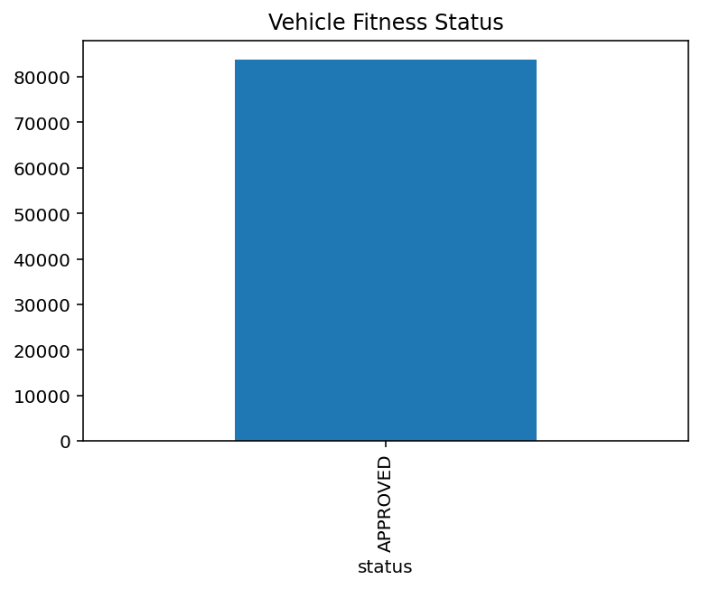
Fig. 1: Vehicle Fitness Status Distribution

Fig. 1 shows that the majority of vehicles fall under the “Approved” category. This indicates a strong imbalance in the dataset, where very few vehicles are categorized as expired or rejected. Such imbalance can limit the ability to perform comparative analysis across different fitness statuses.

Vehicle Class vs Fitness:
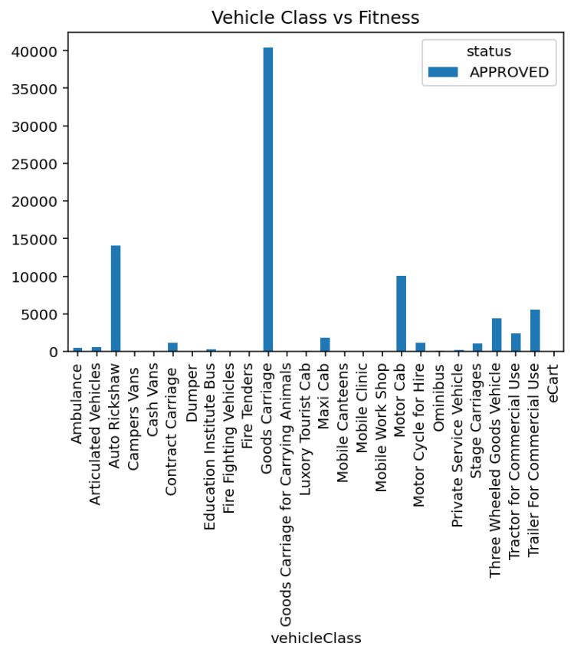

Fig. 2. Vehicle Class vs Fitness Status
Fig. 2 shows that Goods Carriage vehicles dominate the dataset, followed by Auto Rickshaw and Motor Cab categories. This suggests that commercial vehicles contribute significantly to the dataset. The presence of multiple vehicle classes highlights the diversity of transportation systems.

Trend Analysis of Fitness Certificates:
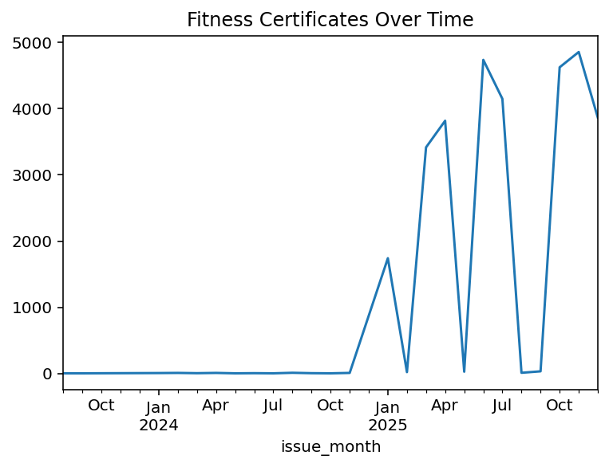Fig. 3: Fitness Certificates Trend Over Time
As illustrated in Fig. 3, Illustrates the trend of fitness certificates issued over time. It can be observed that there are irregular spikes in certain months, particularly in recent periods. These fluctuations may indicate seasonal trends or batch processing of records. Some months show very low values, which may suggest missing data or delayed updates.

Regional Analysis:
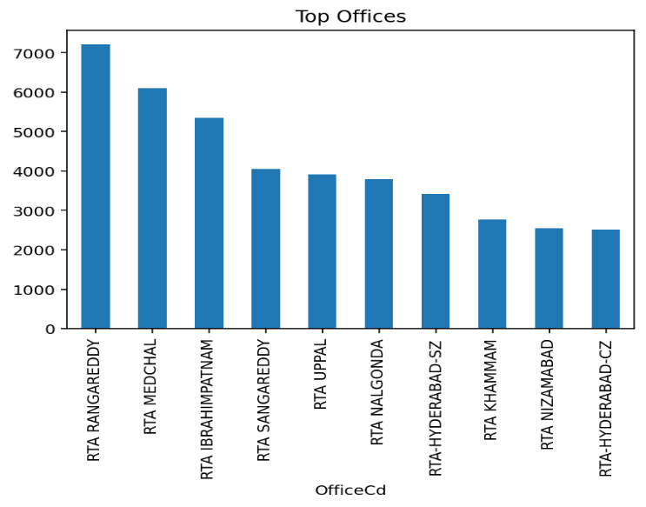
Fig. 4: Top Regional Offices
Fig. 4 shows that certain offices such as RTA Rangareddy and Medchal have significantly higher activity compared to others. This indicates that vehicle inspections are not uniformly distributed across regions. Regional differences may be influenced by population density and administrative workload.

Vehicle Age vs Fitness:
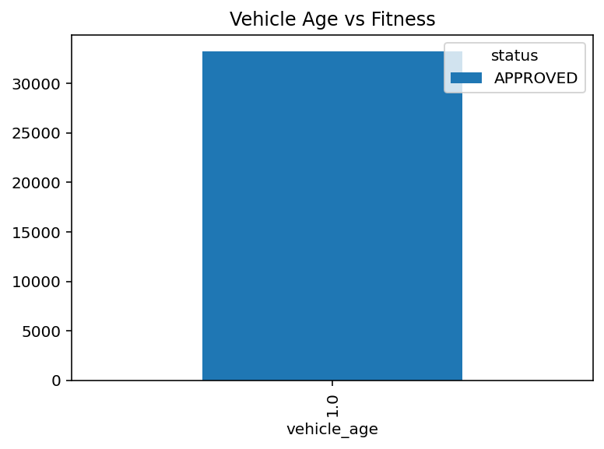
Fig. 5: Vehicle Age vs Fitness Status
Fig. 5 shows that most vehicles fall within a narrow age range, indicating limited variation in vehicle age. This lack of variation affects further analysis and reduces the effectiveness of predictive modeling.

Validity Distribution:
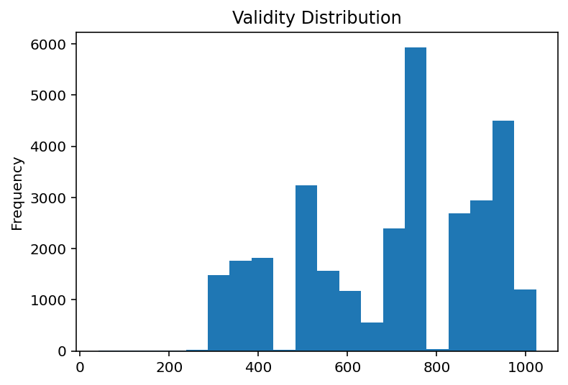
Fig. 6: Validity Days Distribution
The histogram in Fig. 6 multiple peaks in validity duration, indicating that different vehicle categories may have different validity periods. This suggests the presence of varying regulatory policies for different types of vehicles.

Machine Learning Visualization:
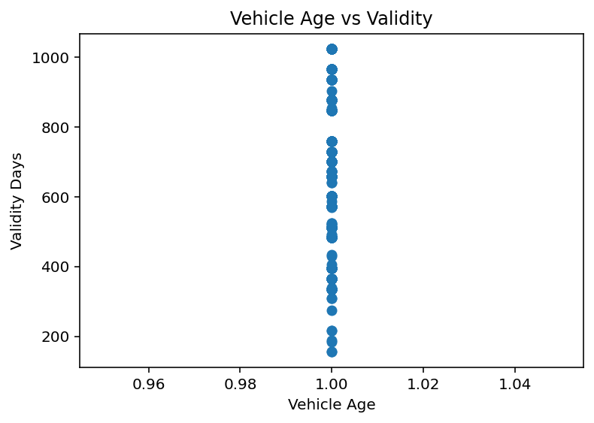
Fig. 7: Vehicle Age vs Validity (Regression Plot)
Fig. 7 shows that data points are clustered vertically, indicating weak correlation between vehicle age and validity duration. This suggests that vehicle age alone is not sufficient for predicting validity.

MACHINE LEARNING MODEL
A Linear Regression model was implemented to predict validity duration based on vehicle age. The dataset was split into training and testing subsets, and the model was trained using Scikit-learn.
The evaluation metrics indicate that the model has limited predictive performance. This is mainly due to the lack of variation in the input feature, which restricts the model’s ability to learn meaningful relationships. Despite this limitation, the model provides a basic understanding of the relationship between vehicle age and validity duration.

RESULTS AND DISCUSSION
The analysis revealed several key insights. First, the dataset is dominated by approved vehicles, indicating strong imbalance. Second, commercial vehicles such as Goods Carriage and Auto Rickshaw contribute the most to the dataset. Third, regional analysis shows that certain offices handle more vehicle inspections than others.
The trend analysis indicates irregular patterns over time, which may be influenced by external factors such as administrative processes. The machine learning model provided limited results due to data constraints, highlighting the importance of feature diversity.

CONCLUSION
This project demonstrates how data analysis and machine learning techniques can be applied to real-world transport datasets. The use of visualization helped uncover patterns and trends, while machine learning provided predictive insights. Although the model performance was limited, the project highlights the importance of data quality and feature selection in predictive modeling.

FUTURE WORK
Future improvements include incorporating additional features such as vehicle type, fuel type, and usage patterns. Advanced machine learning models such as Random Forest and Gradient Boosting can be used to improve prediction accuracy. Additionally, integrating the analysis into an interactive dashboard can enhance usability.

REFERENCES

[1] W. McKinney, “Data Structures for Statistical Computing in Python,” Proc. 9th Python in Science Conf., 2010
[2] J. D. Hunter, “Matplotlib: A 2D Graphics Environment,” Computing in Science & Engineering, 2007
[3] F. Pedregosa et al., “Scikit-learn: Machine Learning in Python,” JMLR, 2011
[4] T. Hastie et al., The Elements of Statistical Learning. Springer, 2009
[5] Python Software Foundation, “Python Documentation,” 2024.
[1] N. Raghavendra Reddy "Data Science Project Post," LinkedIn. [Online]. Available: https://www.linkedin.com/posts/raghavendra-reddy-374446338_datascience-machinelearning-eda-ugcPost-7452781122427572224-52na?utm_source=social_share_send&utm_medium=member_desktop_web&rcm=ACoAAFTIXogBrddUqxLSjjWIuCF8QuDQ2cLuebc


[2] N. Raghavendra Reddy "Data Science Project Post," LinkedIn. [Online].
Available: https://drive.google.com/drive/folders/1LG5Mx_ZPY5W35mRAqBly-rmj0Kv-lWj9?usp=drive_link

